Title: Day 4 – Networking (Socket Programming Simulation) for IoT Smart Home Dashboard

Date: 11 Sept 2025
Name: Nihar Ashraf

Introduction:
On Day-3, I implemented the Device Registration API and integrated MySQL to store gadget metadata.
On Day-4, the focus shifted to Networking Simulation and extending device management features. Since real IoT devices are not available, I simulated devices using TCP socket programming. This allowed the gateway (Java console app) to communicate with devices before updating their status in the database.
Additionally, I implemented a Remove Gadget option, so customers can delete devices they no longer want to manage.

System Design Overview:
- Each IoT gadget (TV, AC, Fan, Light, Robo Vac & Mop) is simulated as a TCP Server (DeviceSimulator).
- The gateway (JavaApp) uses a DeviceClient to connect to these servers over localhost ports (e.g., tv-1 → 9001, fan-1 → 9002).
- A DevicePortMapper maps device IDs to their assigned ports.
- When a customer changes gadget status in the console:
  - Gateway sends a command (SET ON / SET OFF) to the corresponding device simulator.
  - Device simulator updates its internal state and replies OK.
  - Gateway logs telemetry and updates the gadget status in MySQL.
- A new Remove Gadget option was added, allowing the user to delete gadgets from their account using GadgetDAO.deleteByDeviceId(...).

Implementation Details:
Classes Added / Modified
- DeviceSimulator.java → TCP server simulating a device.
- DeviceClient.java → TCP client in gateway to send commands.
- DevicePortMapper.java → Helper class mapping deviceId → port.
- JavaApp.java → Updated changeGadgetStatus to contact device simulators before updating DB. Added new menu option Remove Gadget.
- GadgetDAO.java → Added deleteByDeviceId(...) method to remove a gadget from the database.
Supported Device Commands
- STATUS → Returns ON/OFF.
- SET ON → Turns device ON, replies OK.
- SET OFF → Turns device OFF, replies OK.

Testing Performed:
Test Case 1 – Successful Device Communication
- Started simulator: DeviceSimulator ac-1 9003.
- Logged in to JavaApp, added gadget ac-1.
- Changed gadget status to ON.
Simulator console:
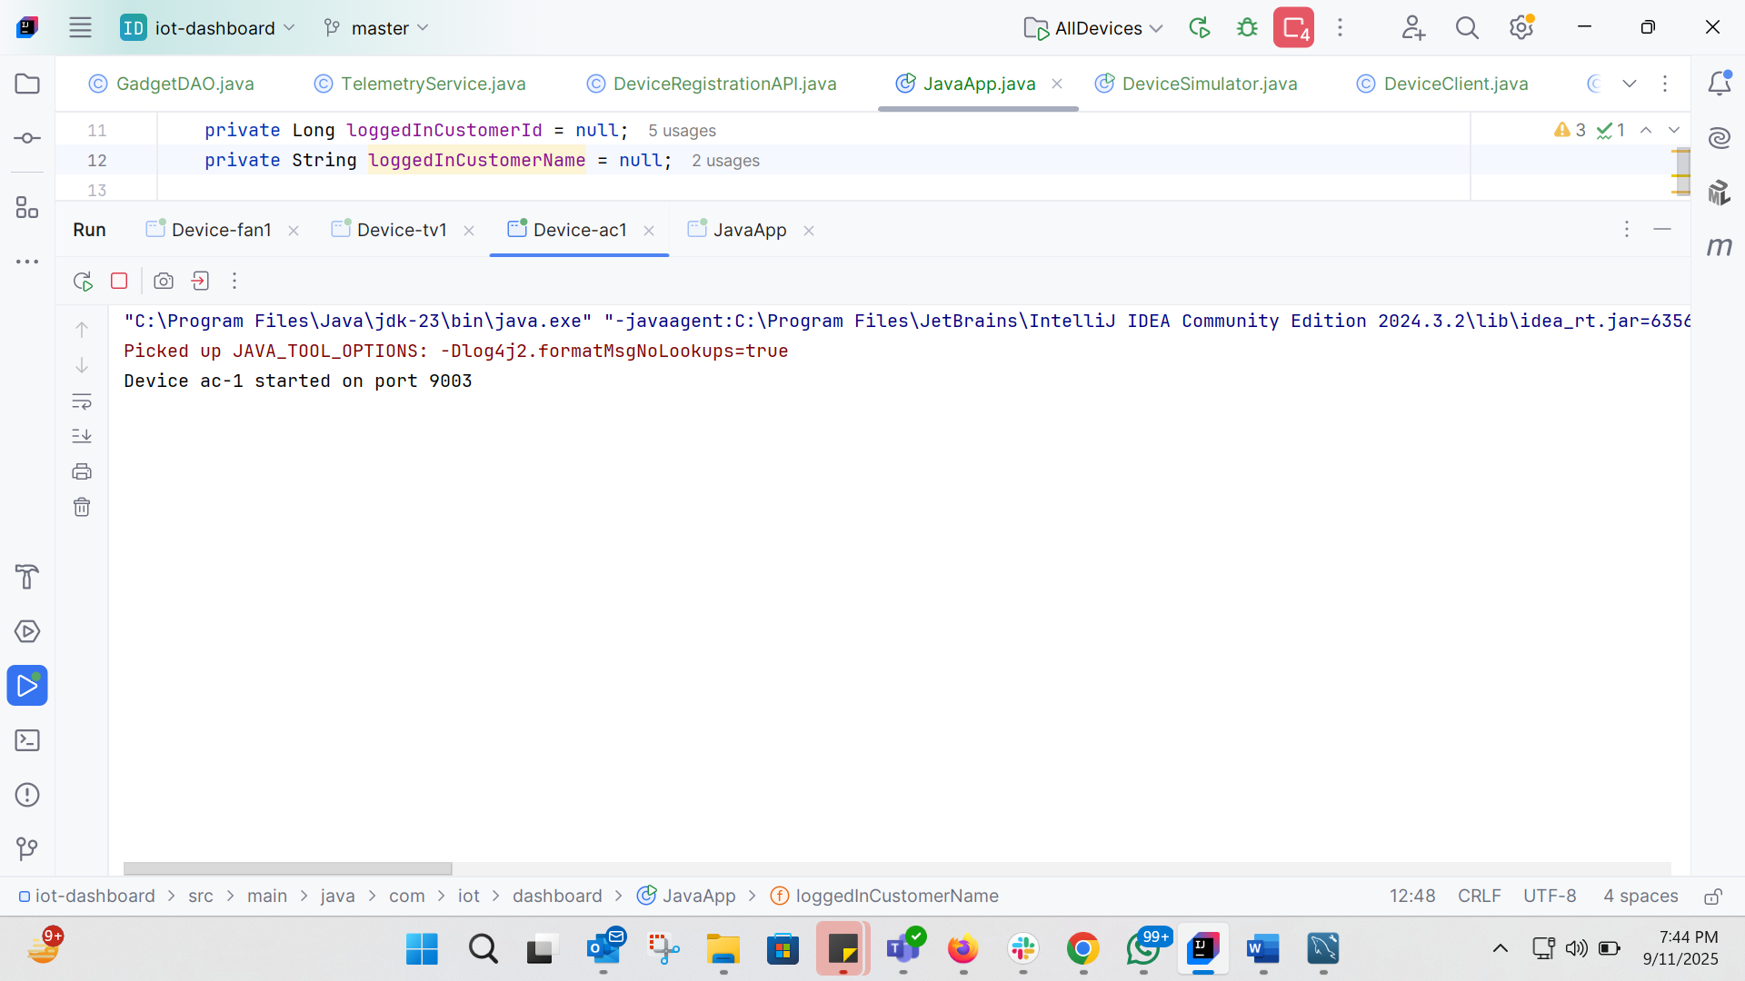

Gateway console:
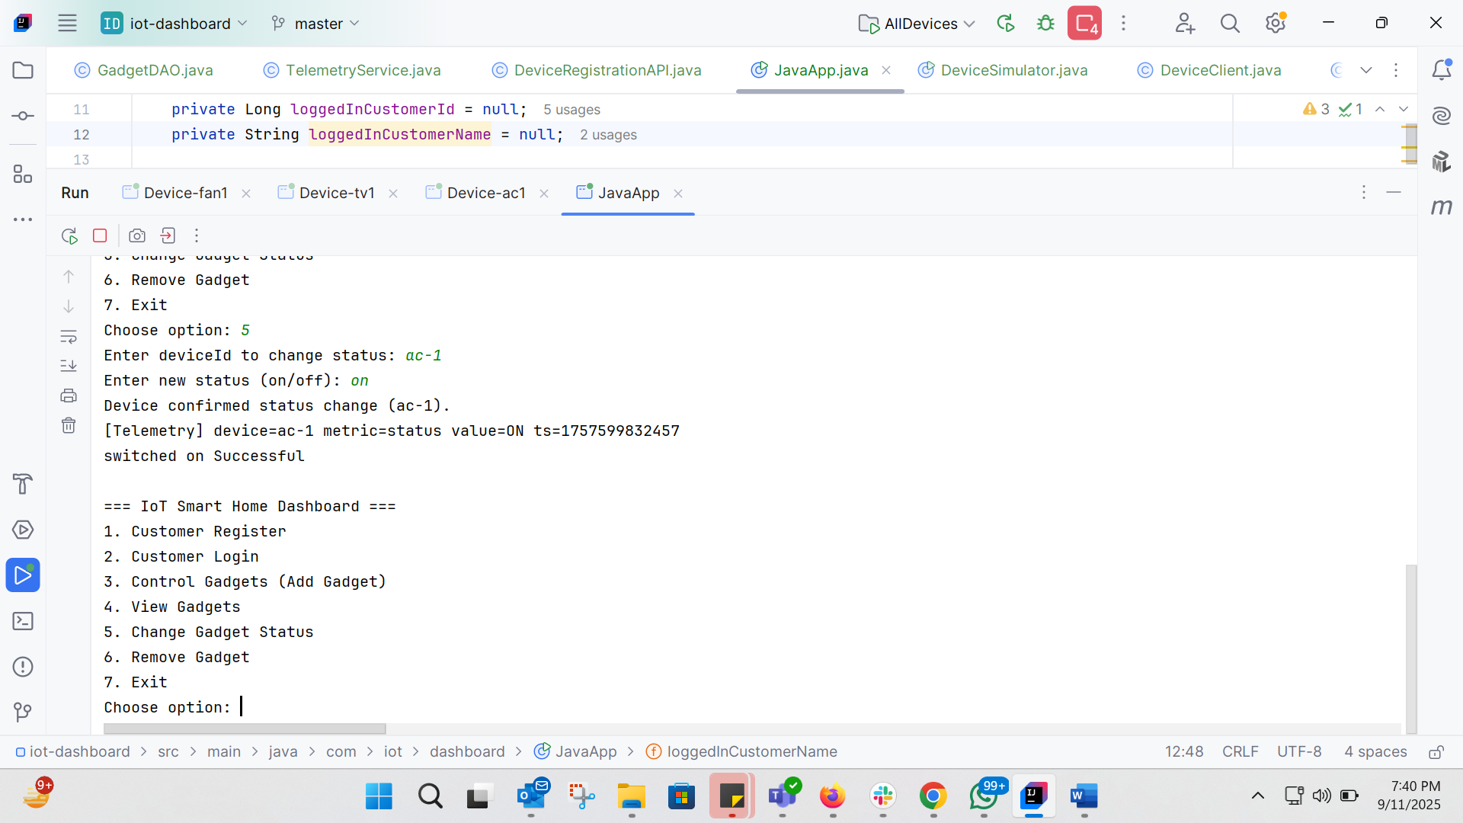
Database (MySQL):
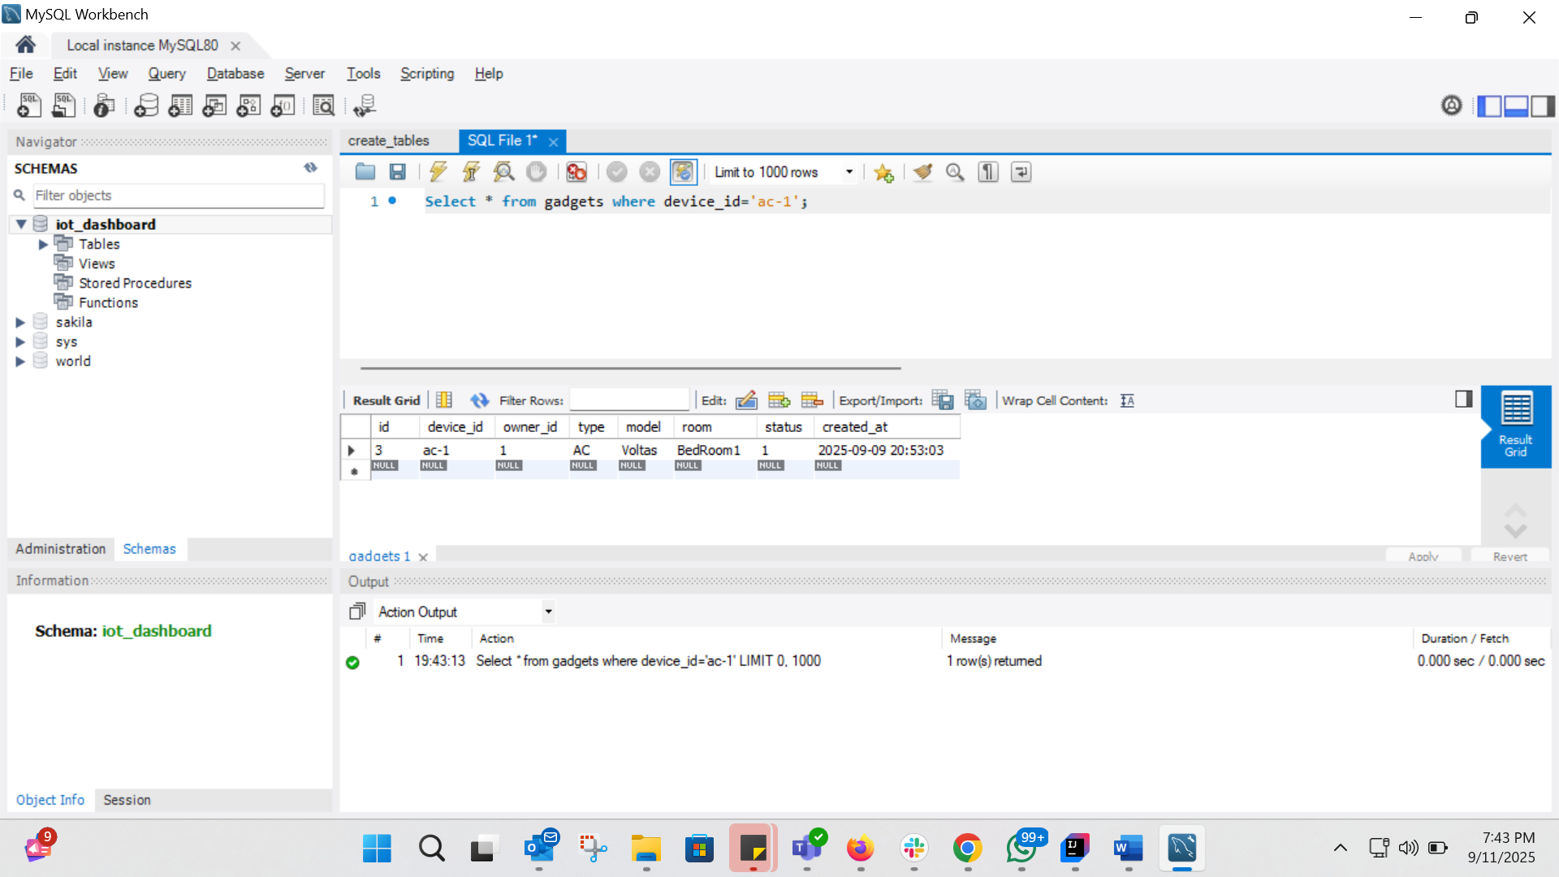

Test Case 2 – Device Unreachable
- Stopped ac-1 simulator.
- Tried to switch ac-1 ON from gateway.

Simulator console:
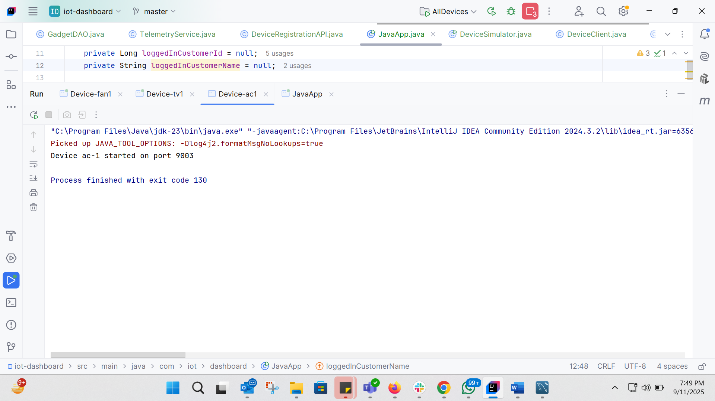

Gateway console:
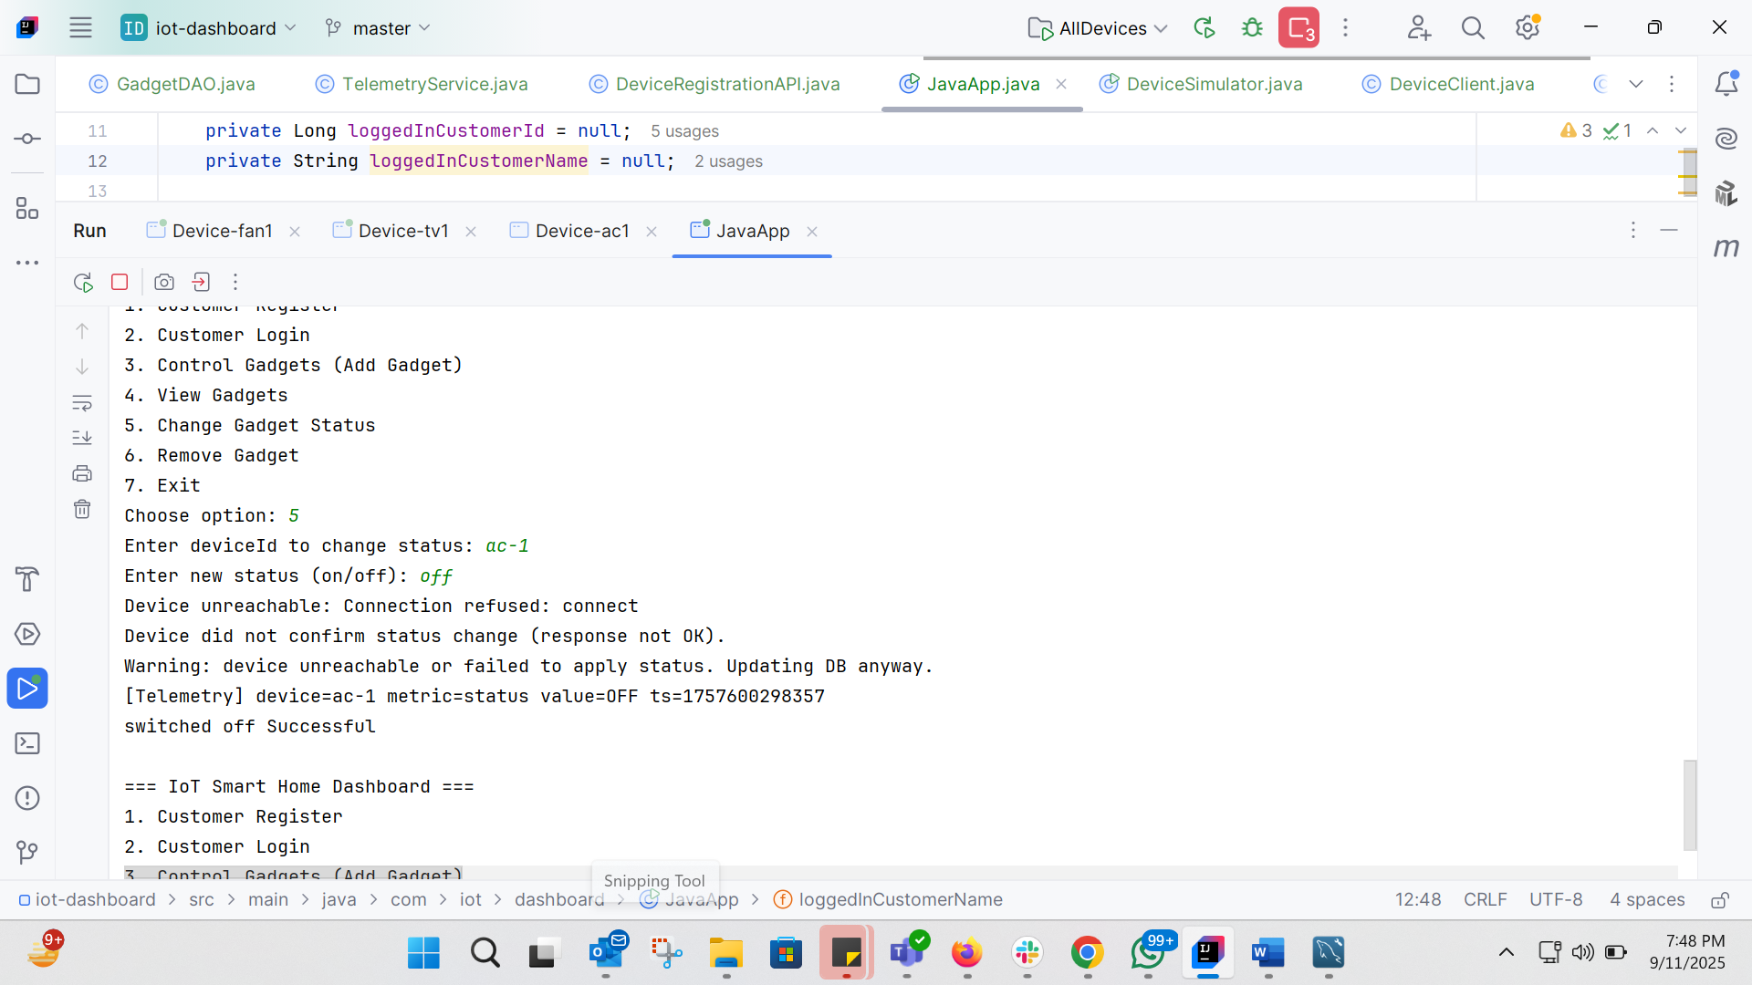

Database (MySQL):
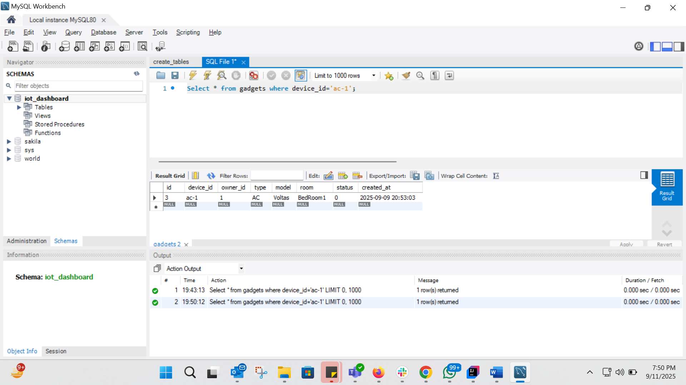
Row for ac-1 still updated, ensuring DB consistency.

Test Case 3 – Remove Gadget
- Logged in to JavaApp.
- Selected option 6. Remove Gadget.
- Entered deviceId: ac-1.

Gateway console:
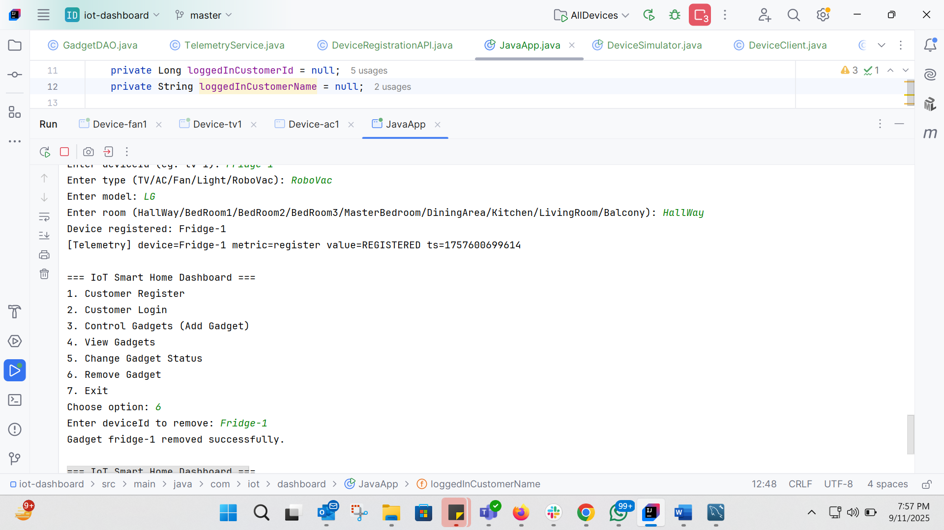
Database (MySQL):
After Adding:
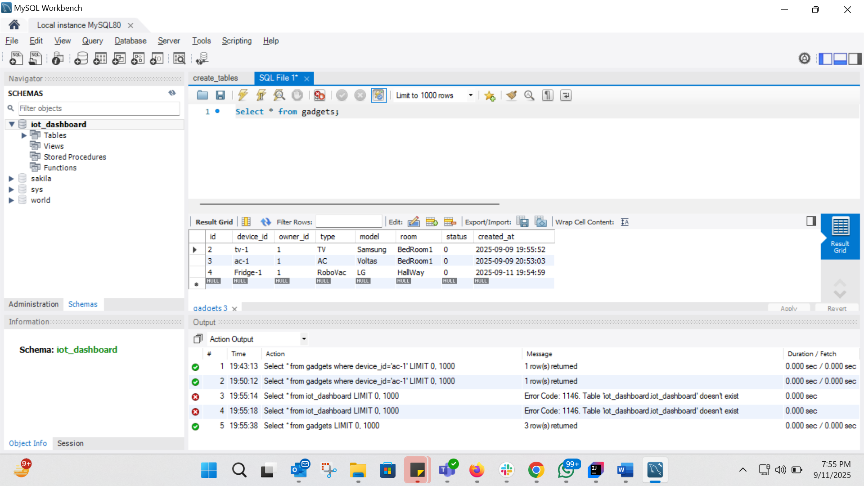
After removing:
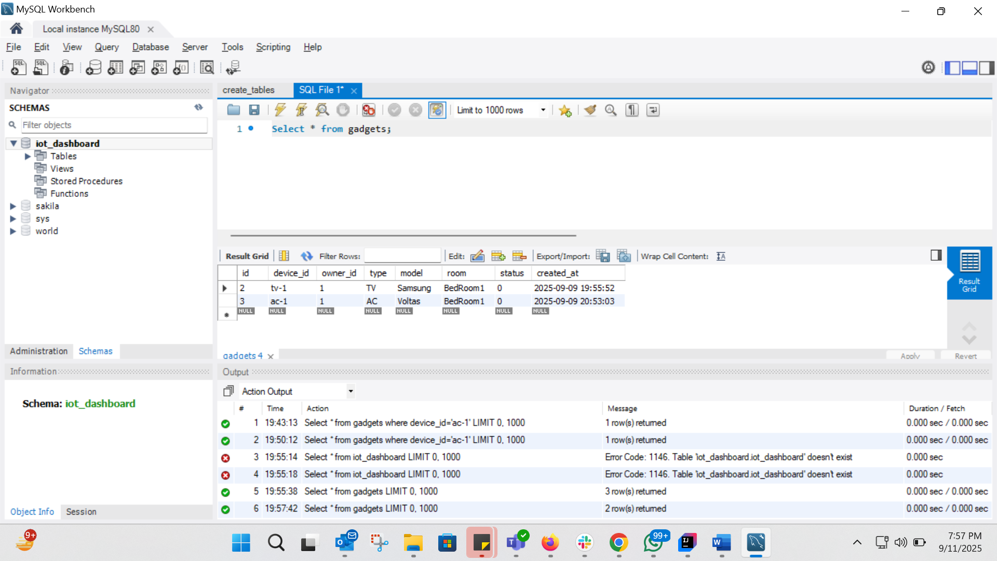

Conclusion:
On Day-4, I implemented the networking simulation using socket programming to mimic IoT devices and integrated it with the gateway application. The gateway can now send commands to device simulators, receive acknowledgements, and update the MySQL database. Additionally, a Remove Gadget feature was introduced to allow customers to delete devices from their account.
This ensures the system now supports the full device lifecycle: register → control → view → delete, with realistic communication between the gateway and simulated IoT devices.

